ALGEBRA II
Practice Problems for 5.1-5.3 Name__________________________

Show all work on a separate piece of paper.

Find a quadratic model the set of values using a system of equations.
- (–1,6), (1,4), (2,9)
Identify the vertex and the axis of symmetry of each parabola.
- 3.
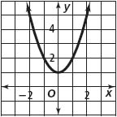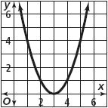

Determine whether each function is linear or quadratic. Identify the a, b, and c values.
- y =-2(x - 3)² 5. y = 4($x^{2}$ – 5x +1) –4x² 6. y = 2x(x – 1) – (3x - 3)
For the parabola below, identify points corresponding to P and Q.

7.
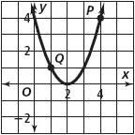

State whether the function has a maximum or a minimum and find its coordinates.

8. y = –x² - x + 6 9. y = -2x² - 3x – 4 10. y = 2x² +5

Graph each function by hand with a minimum of 5 points Label the vertex and the axis of symmetry.
11. y = - x² –4x + 1 12. y = 2x² + 4x - 3
Identify the vertex. Graph each function by hand with a minimum of 5 points.

13. $y={(x-2)}^{2}-3$ 14. $y=\frac{1}{2}{\left(x-1\right)}^{2}-1$ 15. $y=-2{(x+1)}^{2}-5$

Write each function in vertex form. Do not graph.

16. $y=2x^{2}+8x+3$ 17. $y=x^{2}+4x+3$ 18. $y=-2x^{2}-8x$

19. Write the equation of the parabola, in vertex form, with vertex (3, 2) and
passing through the point (2, 4).

You may use your calculator for the following problems.

20. A toy rocket is shot upward from ground level. The table shows the height of the rocket at different times.
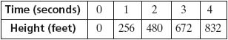
- Find a linear model and a quadratic model for this data.
- State the r and r² values and determine which model is the better fit.
- Use the model of best fit to estimate the height of the rocket after 1.5 seconds.
21. Suppose you are tossing an apple up to a friend on a third-story balcony. After t seconds, the height of the apple in feet is given by h = –16t² + 38.4t + 0.96. Your friend catches the apple just as it reaches its highest point. How long does the apple take to reach your friend, and at what height above the ground does your friend catch it?
22. The barber’s profit p each week depends on his charge c per haircut. It is modeled by the equation p = – 200c² + 2400c – 4700. What price should he charge for the largest profit?
23. The path of a baseball after it has been hit is modeled by the function
h = – 0.0032d² + d + 3, where h is the height in feet of the baseball and d is the distance in feet the baseball is from home plate. What is the maximum height reached by the baseball? How far is the baseball from home plate when it reaches its maximum height?

